# Pizza SQL Queries

1. KPI’s
2. **Total Revenue :**

select sum(total_price) as Total_Revenue from pizza_sales

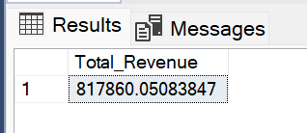

1. **Average Order Value**

select sum(total_price) / count(distinct(order_id)) from pizza_sales

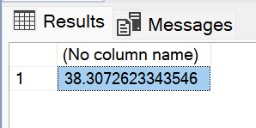

1. **Total Pizza Sold**

select sum(quantity) AS Total_pizza_sold from pizza_sales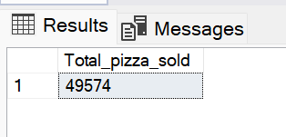

1. **Total order Placed**

select count(distinct(order_id)) AS Total_orders from pizza_sales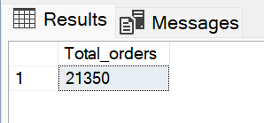

1. **Average Pizza Per Order**

select cast(cast(sum(quantity) as decimal(10,2))/cast(count(distinct(order_id))as decimal(10,2))as decimal(10,2)) AS Avg_pizza_per_order from pizza_sales

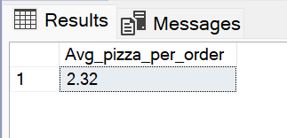

1. Daily and Monthly Trends
2. **Daily Trend for Total Order:**

SELECT DATENAME(DW,order_date) as Order_day, count(distinct(order_id)) as Total_orders

from pizza_sales

group by DATENAME(DW,order_date)

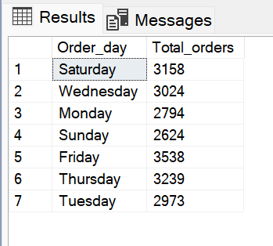

1. **Monthly Trend for Total Order:**

SELECT DATENAME(MONTH, order_date)as month_name, count(distinct(order_id)) as Total_order

from pizza_sales

group by DATENAME(MONTH, order_date)

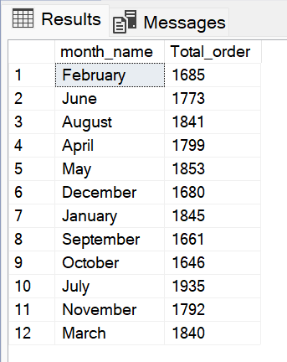

1. Sales By Percentage

**1. Sales by Percentage by Pizza Category**

select pizza_category,sum(total_price)as Total_Sales, sum(total_price)* 100/(select sum(total_price) from pizza_sales) as Perc_sales

from pizza_sales

group by pizza_category

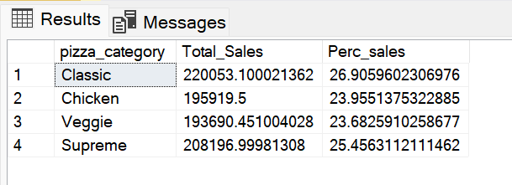

1. **Sales by Percentage by Pizza Size**

select pizza_size,sum(total_price)as Total_Sales, sum(total_price)* 100/(select sum(total_price) from pizza_sales) as Perc_sales

from pizza_sales

group by pizza_size

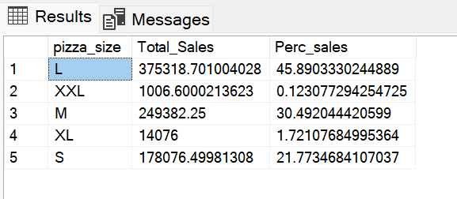

1. Sales By Percentage
2. **Top 5 Pizzas by Sales**

select TOP 5 pizza_name,sum(total_price) as Total_Price

from pizza_sales

group by pizza_name

order by Total_Price desc

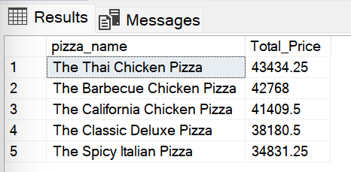

1. **Bottom 5 Pizza Name by Sales**

select top 5 pizza_name,sum(total_price) as Total_Price

from pizza_sales

group by pizza_name

order by Total_Price

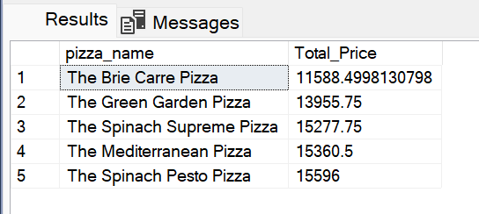

1. **Top 5 Pizza Name by quantity**

select top 5 pizza_name, sum(quantity) as Total_Quantity

from pizza_sales

group by pizza_name

order by Total_Quantity desc

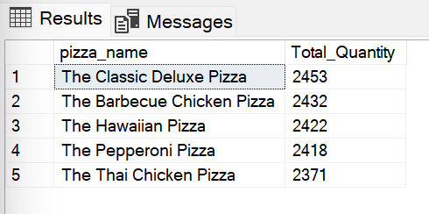

1. **Bottom 5 Pizza Name by Quantity**

select top 5 pizza_name, sum(quantity) as Total_Quantity

from pizza_sales

group by pizza_name

order by Total_Quantity asc

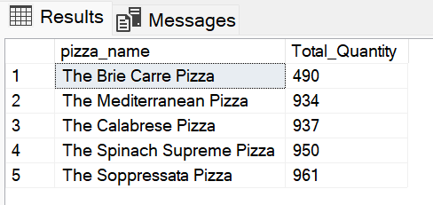

1. **Bottom 5 Pizza Name by Total Orders**

select top 5 pizza_name, sum(distinct order_id) as Total_orders

from pizza_sales

group by pizza_name

order by Total_orders asc

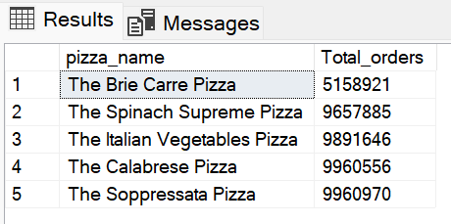

1. **Top 5 Pizza Name by Total Orders**

select top 5 pizza_name, sum(distinct order_id) as Total_orders

from pizza_sales

group by pizza_name

order by Total_orders desc

